Provide a short list of IoT & OT devices found,
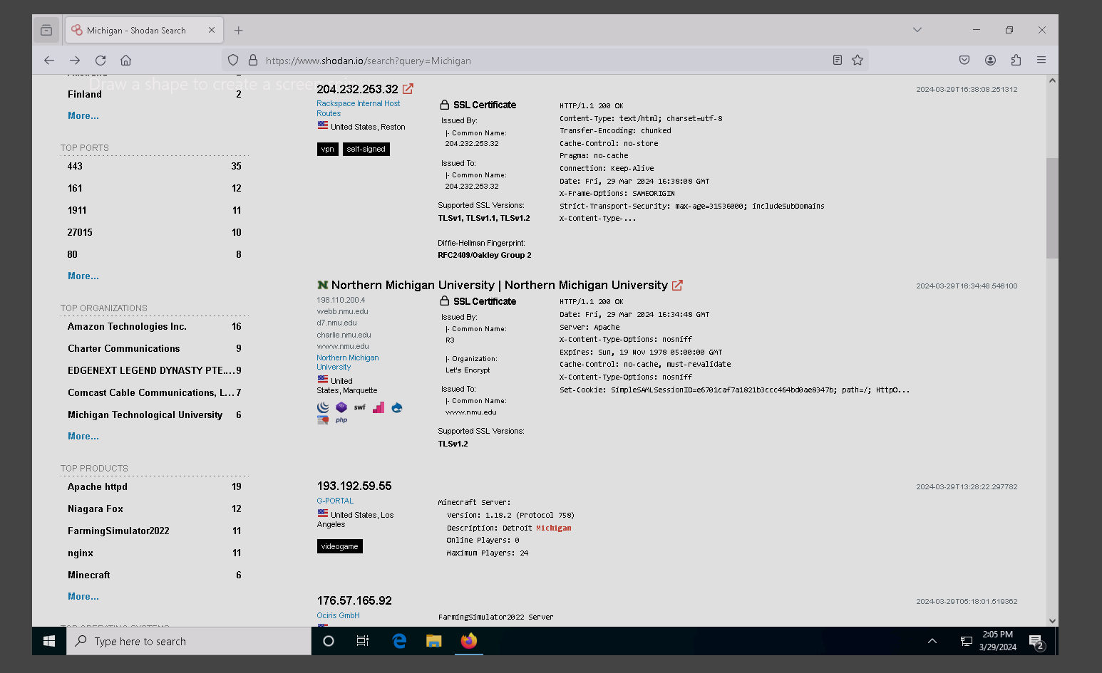

Are there any OT devices located in SE Michigan? Yes.
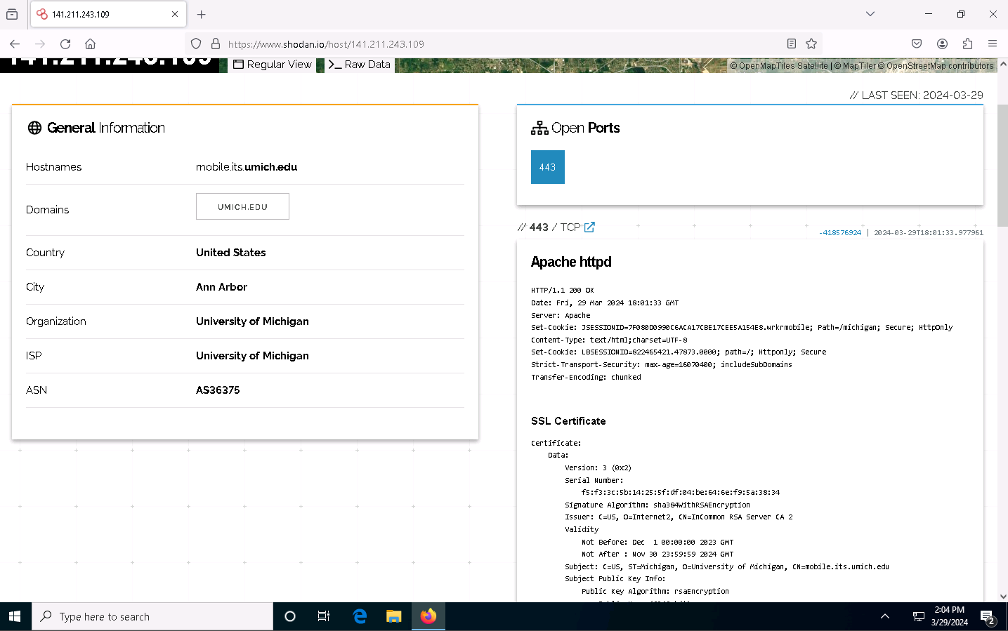
What is OT?
OT stands for Operational Technology. It refers to the hardware and software used to manage industrial operations, particularly those that are direct, monitor, and control physical devices and processes.

What type of devices did you find in the pcap files?
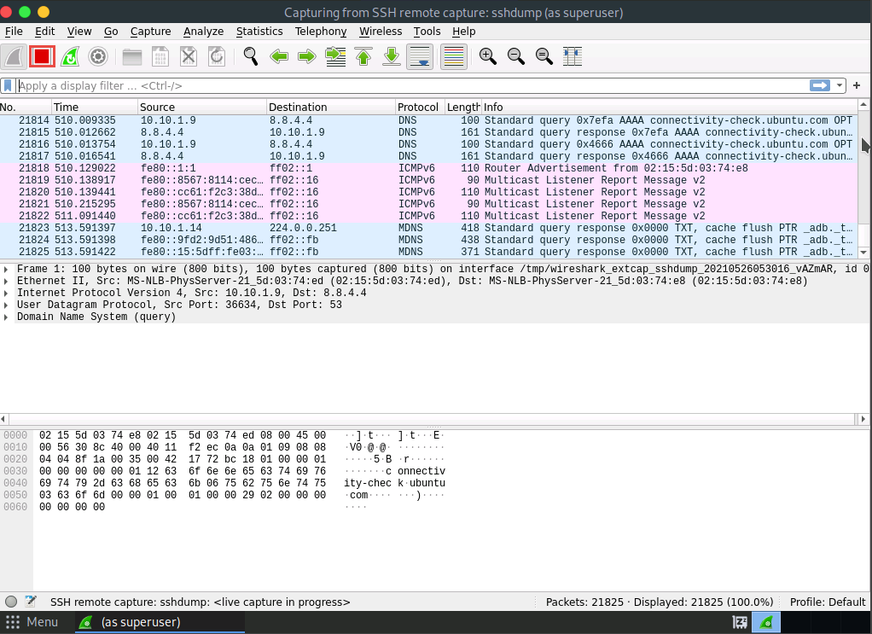

What IoT protocols did you find?
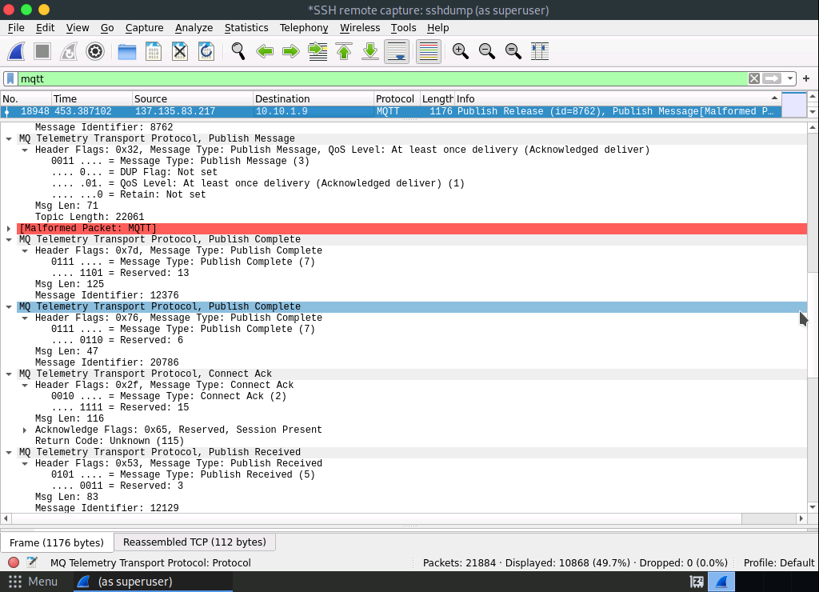
- What worked well in the lab?
The ubuntu part was running very smoothly, compere to Windows and Parrot Servers.
- What parts were troublesome?
No trouble in this lab just the platform does not give enough time for the lab so I had to redo it once since 30 minutes was not sufficient.
- Over all impression of the lab?
Pretty fun and cool finding OT in Michigan I was able to even find a Minecraft server.

